
Community Newsletter
December 2025

Message from the Board of Directors

With the upcoming season, we would like to remind all owners that it is our responsibility to make our guests and renters aware of the rules and regulations of our community. Should the association incur any costs due to negligence from a guest/renter, that cost will be passed on to the owner.

Current Project Updates

Carports: We are working on the repairs to the carports to fix the damage caused by the hurricanes last year. The contract has been awarded, and the engineering is complete. The county reached its review date on 11/06/25, but unfortunately, they have now requested additional information which will delay the project. NO NEW INFORMATION.

Hurricane Window Installation: Building 1 – All units have been closed up for the season, and the scaffolding has been taken down and stored by the gazebo. During the “off” season, we will need to open unit 303 and install a new webbed steel beam which has now been delivered and is in storage on the property.

Hurricane Window Installation: Building 2 – The “framework beam” has been installed and the project has moved into installation phase of the hurricane sliders.

Beach Installation – The Gabion project near the waterside gazebo and the adjoining beach is currently on hold. The shoreline surveys have been completed, and the required paperwork has been submitted to multiple county entities. Completion of the project will resume with the issuance of the appropriate permits and should be completed within two weeks. NO NEW INFORMATION

Pool Furniture – About 50% of the beach furniture has been sent out for refurbishing. We expect to have the furniture back in place by end of December. NO NEW INFORMATION

Repair of concrete slabs (front edge) on lanais – Buildings 1,2 and 3 Preliminary inspection to identify damaged lanais and create an estimate to remove the front panel to generate the scope of work. End of December is the estimated completion date of this section of the process.
- Have all required fabrication completed during “season” NO NEW INFORMATION
Buildout and lanai refurbishing – Buildings 1 through 8
- The engineering for buildings 4 through 8 is complete and the “bid document” is being prepared.
- The engineering for buildings 1,2, and 3 will be completed in the first quarter of 2026.
Roof Cleaning- Equipment problems pushed the completion date into conflict with our returning membership causing this project to be placed “on hold” until the Summer of 2026.

Staffing Update

At the executive board meeting of 11/11/25, the BOD approved the addition of an administrative assistant to our staff and finalized the revised 2026 budget to include funding for this position. We were originally looking for a candidate from our temp employment house, but due to cost, we have decided to expand our search to the local technical colleges.

New Assessment Payment Amounts at a Glance!
Just find your current payment and the new amount will be to the right.

Future Projects on the Horizon

- Painting Building / Railing and Stairs
- Select paint engineer for inspection and determine the scope of work.
- This item will be addressed in January of 2026. NO NEW INFORMATION
- Avenue D – Fence or Gate:
- This construction was to be included in the Beautification Grant project.
Not enough groundwork has been done by the Board to proceed with this endeavor this year, but it will be targeted for the completion of an application next year. NO NEW INFORMATION

- Elevator Rebuild:
All three elevators need refurbishing cars/electrical/hydraulic. The plan is to complete one elevator a year. Cost per unit is between $75,000 and $100,000. Due to the extreme financial burden on our reserves for this project, the modification documents required for these units are presently being prepared by the Florida Elevator Company.

This would be an appropriate position to remind our members that ANY and ALL alterations to our units need to be submitted to the office. This action is not meant to be restrictive, but to ensure a consistent standard of construction throughout the property.
Our recent experience has shown us that there are many pitfalls that can be avoided and that owners are not aware of the idiosyncrasies of our buildings and/or the latest local building code alterations. We cannot rely solely on the contractor.

Anyone considering adding hurricane sliders to their lanai in the next building season, needs to submit their plans to the office now. The lead time to structurally prepare the lanais for installation will have to be reviewed before starting this endeavor and could require additional time to address.

Upcoming Calendar of Social Events
Location: Clubhouse
- WEDNESDAY, Januaery14,2026……4:00PM to 5:30 PM – Welcome Back Party.
- WEDNESDAY, February18,2026…….5:30 PM - Trivia Night & Pizza
- WEDNESDAY, March 11,2026 ……….7:00 PM – Movie Night
- WEDNESDAY, April15, 2026 ………….5:30 PM Trivia Night & Pizza
Location: Round Pool
- TUESDAY, March 24, 2026…………….5:00 PM to 9:99 PM End of Season Party
(Rain date: Thursday, March 26,2026)
Your Landscape Committee Update-past two weeks
- Design process underway for the two pool areas to add color and fill out the existing plantings. Proposal to CDM BOD/Management is next step (January date TBD).

- Annuals replaced in Stickney Point Entry beds (Nov. 21 by Troy's Tropics)

- 280 annuals replanted in the two Avenue “D” entrance beds (geraniums) and mailbox/walkway beds for Buildings 1-3 (sunpatiens). Linda Waldera initiated the project--- and ten owner volunteers, led by Brendan Hall, pitched in to brighten up our entrances (Nov. 30-Dec 2). Thank you to Linda, Brendan and all the volunteers!
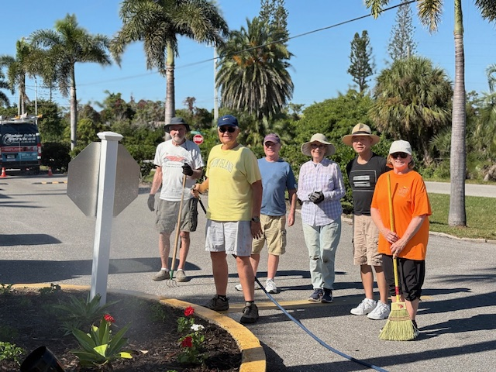
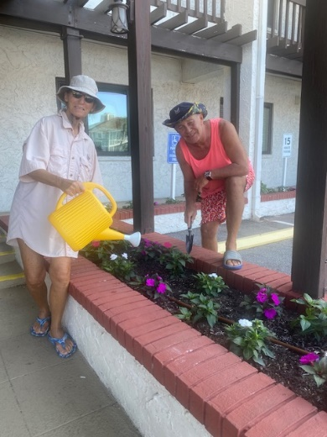
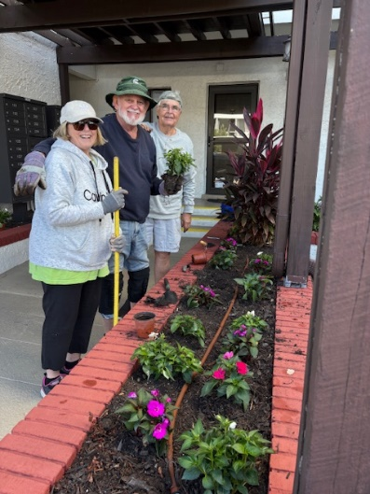

- Beautiful planting of the Stickney sidewalk and Avenue “D”/Stickney beds (per the mockups in our last newsletter), further enhancing the entry to CDM (Dec 3-4 by Troy's Tropics).
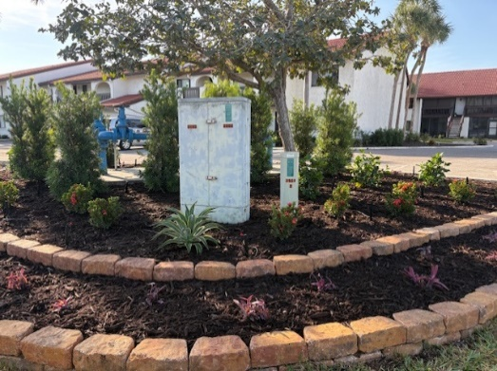
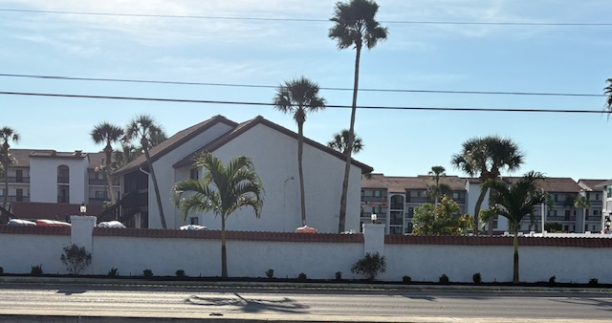
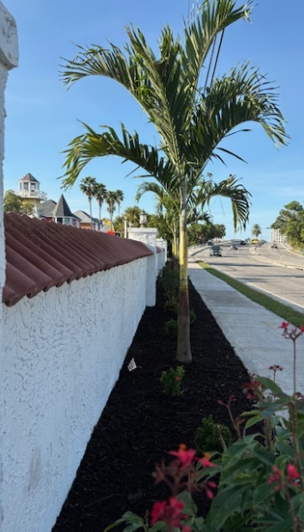
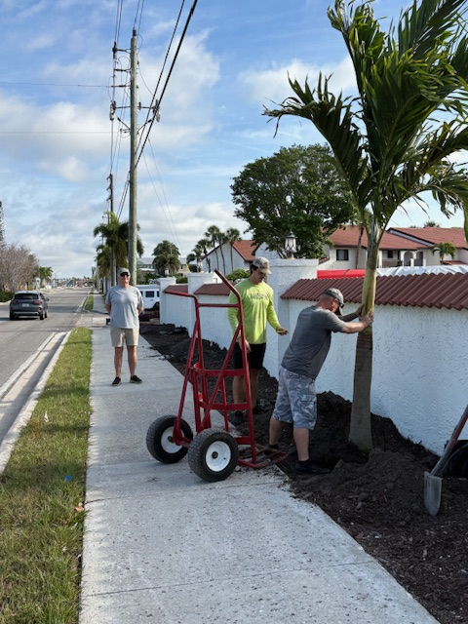

Joe Alix took on the daunting task of quickly and effectively installing all new irrigation where needed for the annuals and for the new sidewalk and Avenue “D” corner beds. Thank you, Joe, for making it all happen so smoothly!

Next up:
- Hibiscus and other colorful plants in high visibility walkway areas and building fronts. CDM maintenance/landscaping team and owner volunteers will implement a planting program (TBD)

- Create a Landscaping Support System initiative to assist the CDM maintenance team in identifying and remedying plant issues as they arise and lend a hand in some plant care areas (e.g.); dead heading, fertilizing, trimming, off-schedule watering, etc.).

- CDM Landscaping Committee Meeting (Jan. TBD)

PLEASE contact the Landscaping Committee if you would like to volunteer--green thumbs not required!! No task is too small as our landscaping will reflect the care we are able to give it.
To ask questions, offer suggestions, or volunteer, please email:
cdmlandscaping34231@gmail.com

Beautifying CDM...one plant at a time!
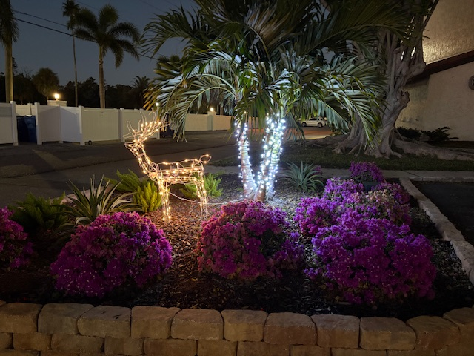

General CDM Information
CDM Website: www.casteldelmare.net
Community Association Manager: Jerry Thomas(cdm1478@gmail.com)
Office Phone Number: (941) 927-1478
Office Hours: Monday thru Friday – 8AM till 4PM
Office email address: cdm1478@gmail.com

Office Address: Castel Del Mare
Condominium Association, Inc.,
1620 Stickney Point Road
Sarasota, FL 34231

Board of Directors
President: Mike Turner (mturner54@hotmail.com)
Vice President: William Jennings (wllliam.j.jennings@gmail.com)
Secretary: Marcus Braz (mjbraz17@gmail.com)
Treasurer: Rick Gorrell (rickgorrell@comcast.com)
Director: Graham Shorter (shorter50@att.net)

Landscape Committee Chairs
Colleen Lohnes (cdmlandscaping34231@gmail.com)
Kathie Westpheling (cdmlandscaping34231@gmail.com)

Maintenance Staff
William” Joe” Alix
Paul Price
Dennis Williams
Social Committee
Arlene & Rick Gorrell (rickgorrell@comcast.net)
Joann & Brendan Hall (jbfhall@gmail.com)
Linda & Jim Waldera (tiezziwaldera44@gmail.com)

Closing Comments:
This is a time to reflect on our many blessings and to enjoy the celebration of the Holiday Season with friends and family. Please be courteous and thoughtful of one another in the true spirit of this season.

Happy Holidays to all and if you are travelling, please be safe….we want to see you back at Castel del Mare in the New Year.

The CDM Board of Directors

