
Community Newsletter
January 2026

Message from the Board of Directors

Happy New Year and welcome back to all our returning association members.

As we start a new season and the property becomes busier, we have a couple of items that we should review to maximize both the owners and the renter’s enjoyment of the facilities.

- Please confine parking to your assigned locations, do not use “Guest” spots for
your personal long term or overnight parking. For those who have a second vehicle please
park in the spots along the wall on Stickney Point Rd. You can use open owners’ spaces,
not in residence, if you receive prior written permission from that owner – filed with the front
office.

- Our plumbing system is 50 + years old. Please do not flush anything other than toilet tissue down the commodes. The “wipes” that say they are flushable, state in small print “not compatible with all sewer systems”. These items catch on the rusted pipes and quickly build into a blockage, which will create a plumbing repair and could result in a charge back to the owner. So, those of you who are renting your units, please inform your tenants of this condition and it would be helpful if you posted a note in your bathrooms to this effect.

- Please do not reserve chairs and/or chaise lounges, we are short of seating until our furniture has been returned from being refurbished. Saving chairs and tables is not allowed to begin with.

Current Project Updates

Carports: The contractor feels that the permits will be issued in the next couple of weeks and to that end you may see a few of their employees on the property doing some preliminary work.

Hurricane Window Installation: Building 2: The final installation should be completed in Unit 406 by the end of January.

Beach Installation – The Gabion project near the waterside gazebo and the adjoining beach is currently still on hold pending issuance of the appropriate permits from multiple agencies.

Pool Furniture – The original delivery date of Dec. 29, was reconfirmed before the Christmas break. Obviously, this has not happened. The follow-up conversation with the supplier reveals that he is running late on deliveries due to employee illness and expects to return our furniture on Jan.19.

Repair of concrete slabs (front edge) on lanais – Buildings 1,2 and 3
- An estimate is being prepared to “open” the front access panels between the lanais to inspect the interior and document the condition of supporting structures of all three towers. This data will enable us to create a laundry list of required fabrications and a budget for the project.
- The goal is to have all required fabrication sourced for completion during “season”
- This is a “Milestone Report” item and is required to either be completed or to substantially in progress by the end of 2026.
Buildout and lanai refurbishing – Buildings 1 through 8
- The engineering for buildings 4 through 8 is complete and the “bid document” will be generated by the end of January. The engineering for buildings 1,2, and 3 will be completed in the first quarter of 2026.
Roof Cleaning

- The existing contract has been cancelled.

Staffing Update

The search for a qualified administrative assistant is still underway.

Future Projects on the Horizon

- Painting Building / Railing and Stairs
- Select paint engineer for inspection and determine the scope of work.
- This item will be addressed in January of 2026, but due to funding, the physical aspects of this project will probably not start until 2027.
- Avenue D – Fence and/or Gate:
- This construction was to be included in the Beautification Grant project.
Not enough groundwork has been done by the Board to proceed with this endeavor this year, but it will be targeted for the completion of a Grant application next year. NO NEW INFORMATION

- Elevator Rebuild:
All three elevators need refurbishing cars/electrical/hydraulic. We’re looking to rebuild one unit per year.

Upcoming Calendar of Social Events
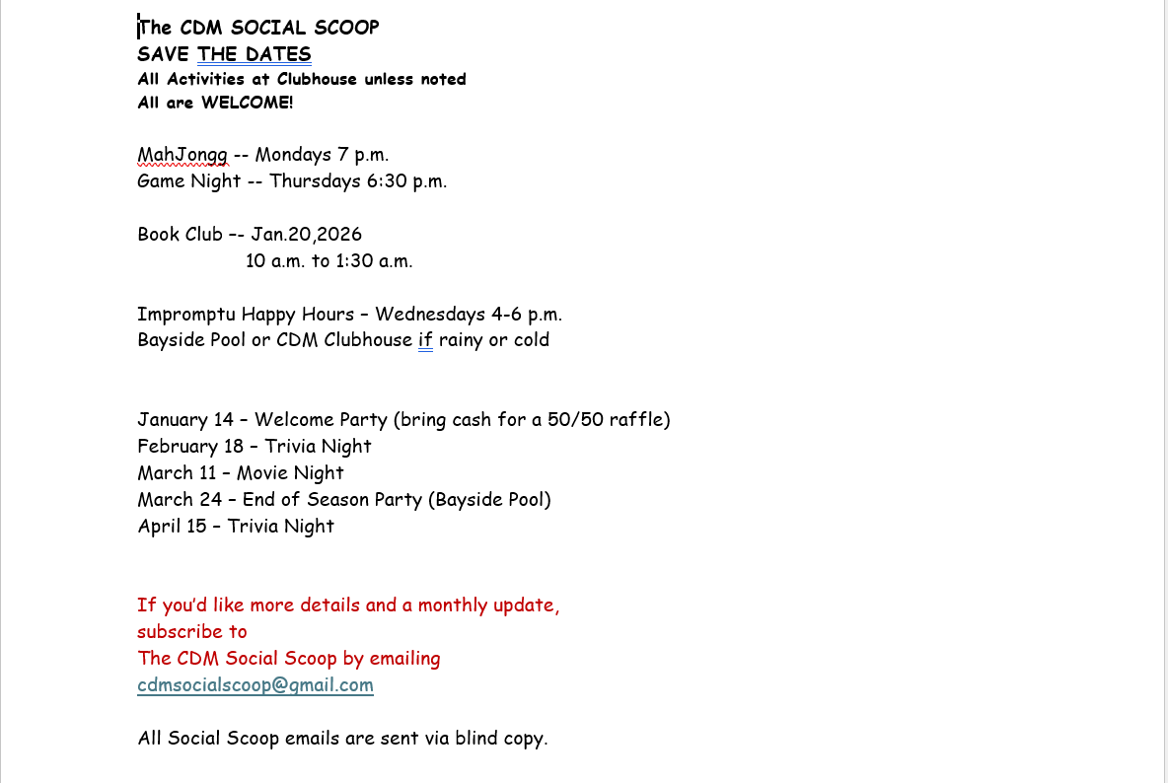
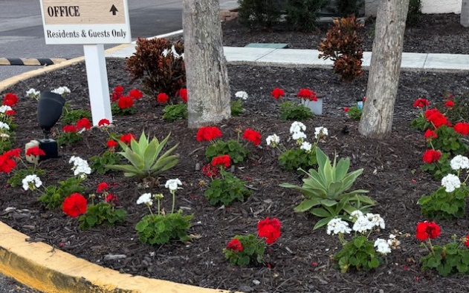
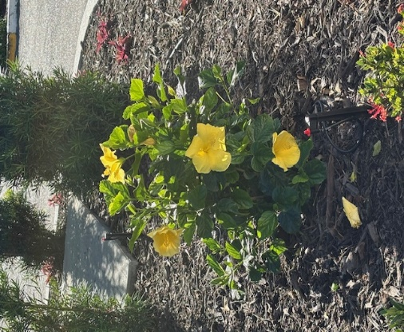
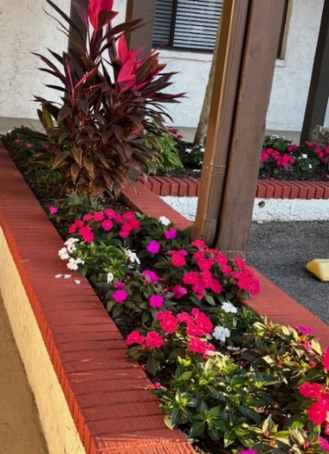
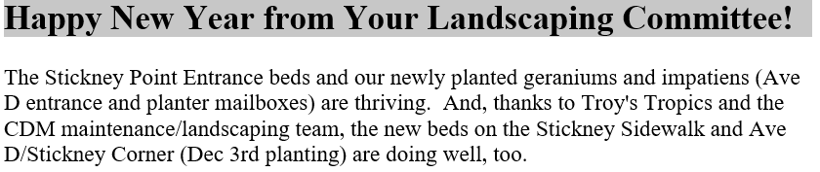
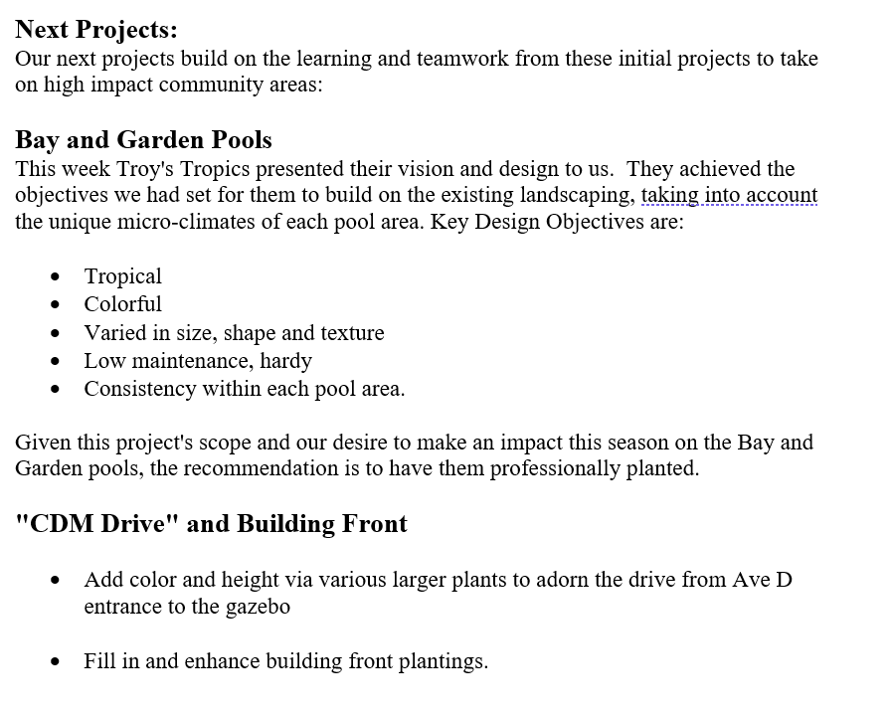
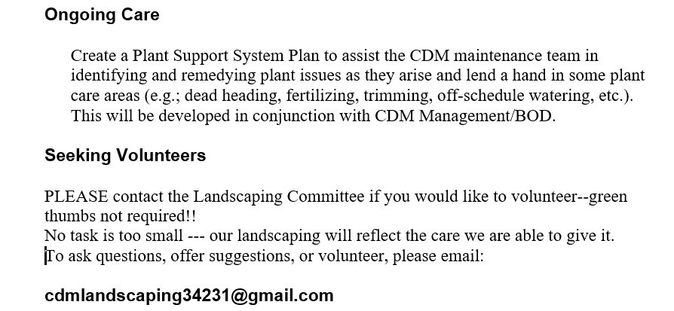

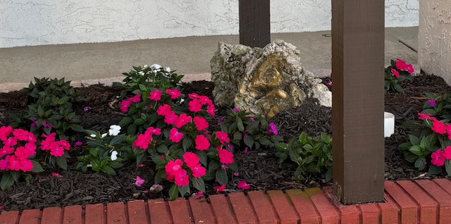
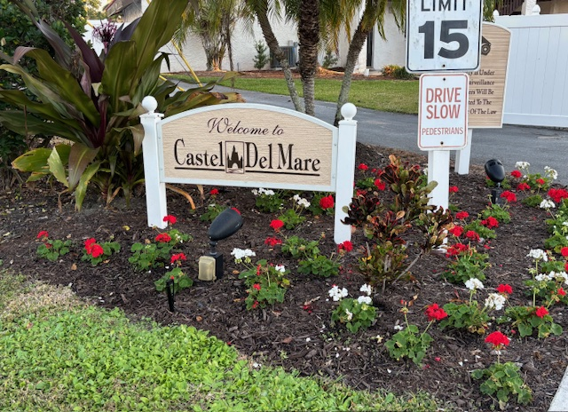
Beautifying CDM...one plant at a time!

Closing Comments:

February 7, 2026, is our annual meeting and election of new board members – four total. Please remember that when selecting candidates that these are “working” positions which need to be filled by individuals with experience and a willingness to roll up their sleeves and work together to improve the community in which we live.

Most importantly……………. PLEASE VOTE!!!!!!!!!!!!

The CDM Board of Directors

General CDM Information
CDM Website: www.casteldelmare.net
Community Association Manager: Jerry Thomas LCAM (cdm1478@gmail.com)
Office Phone Number: (941) 927-1478
Office Hours: Monday thru Friday – 8AM till 4PM
Office email address: cdm1478@gmail.com

Office Address: Castel Del Mare
Condominium Association, Inc.,
1620 Stickney Point Road
Sarasota, FL 34231

Board of Directors
President: Mike Turner (mturner54@hotmail.com)
Vice President: William Jennings (wllliam.j.jennings@gmail.com)
Secretary: Marcus Braz (mjbraz17@gmail.com)
Treasurer: Rick Gorrell (rickgorrell@comcast.com)
Director: Graham Shorter (shorter50@att.net)

Landscape Committee Chairs
Colleen Lohnes (cdmlandscaping34231@gmail.com)
Kathie Westpheling (cdmlandscaping34231@gmail.com)

Maintenance Staff
William” Joe” Alix
Paul Price
Dennis Williams
Social Committee
Arlene & Rick Gorrell (arlene_gorrell@comcast.net)
Joann & Brendan Hall (jbfhall@gmail.com)
Linda & Jim Waldera (tiezziwaldera44@gmail.com)

