

1620 Stickney Point Rd. | Sarasota, FL 34231

Tel: 941-927-1478 Fax: 941-923-1713
SEPTEMBER COMMUNITY NEWSLETTER

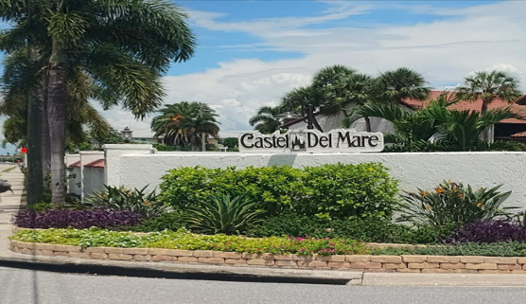

  - Board Members
  - Marcus Braz – President Rick Gorrell – Secretary
Graham Shorter – Vice President Brendan Hall – Director
Mark Alfieri – Treasurer Jim McGuire – Director

PROGRESS AROUND THE COMMUNITY
Several important maintenance, repair, and improvement projects are moving forward throughout Castel Del Mare. We appreciate everyone’s patience and cooperation as we continue working to protect and enhance our community.
BUILDING IMPROVEMENTS
Structural & Slab Repairs
Testing related to structural and slab repairs in Buildings 1-3 has been completed. The next step is to review the engineers’ recommendations and develop detailed project specifications.
The engineer’s report is expected by September 18, 2026.
The slab repairs may be coordinated with repairs to the two-story pop-out areas. Combining these projects could help streamline construction and potentially reduce overall costs.
WALKWAY LIGHTING REPLACEMENT
The Association is pleased to announce the completion of the walkway lighting replacement project.

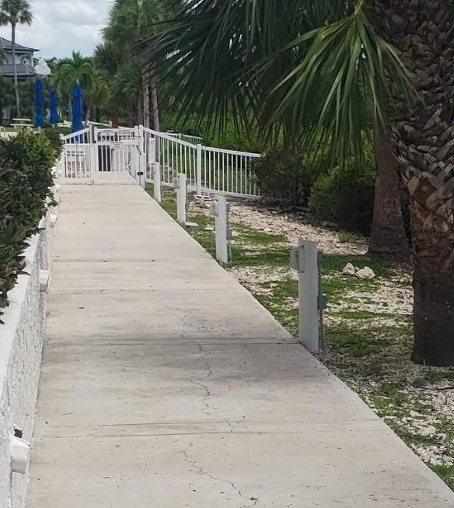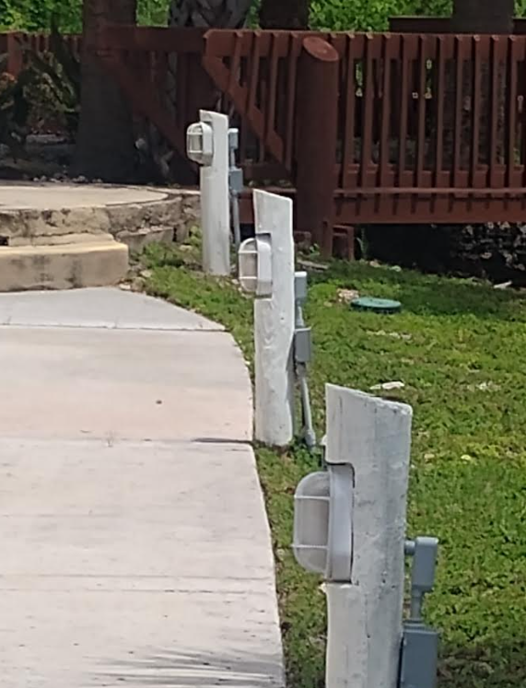
The existing walkway lights have been replaced with all-new lighting and wiring, providing a more reliable and consistent lighting system throughout the property. This upgrade will help improve visibility along our walkways while also addressing aging wiring and equipment.
This improvement is another step toward maintaining our community and ensuring our common areas remain safe, functional, and well cared for.
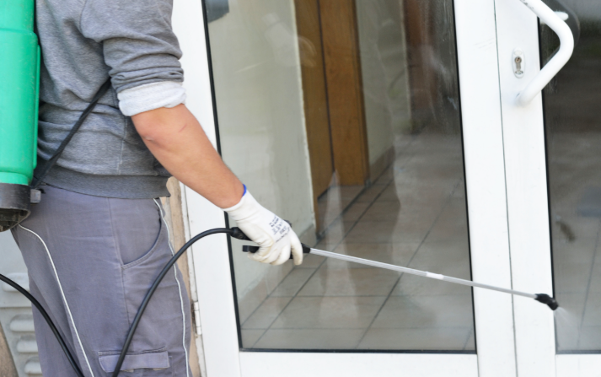
ANNUAL BUG SPRAY APPLICATION
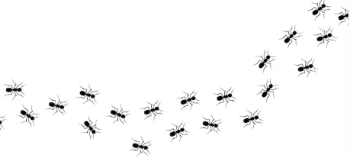

The Association’s Annual Bug Spray Application has been completed for Buildings 1 through 8. This preventative treatment helps protect our buildings and grounds during the active termite season.
We encourage all residents to remain alert for signs of termite activity, including small piles resembling coffee grounds, discarded wings, or other unusual activity around windowsills and doorframes.
If you notice any signs of concern, please report them to Management promptly so they can be investigated and addressed as needed.

IMPORTANT CONTRACTOR REMINDERS
As a friendly reminder: If you are having work done in your home, please remind your contractors to check in with the office before beginning any work. The office will help identify designated areas for cutting, preparing materials, and other work activities. This helps protect our landscaping, irrigation systems, and common areas from accidental damage.
We also ask that contractors use the laundry room sinks for clothing-related purposes only. Please do not rinse, clean, or dispose of construction materials, tools, paint, debris, or other non-clothing-related items in the laundry room sinks or storm drains.

BUILDING STAIRWAY PICKETS
Stairway pickets and related components are being replaced with additional work planned as the project progresses.
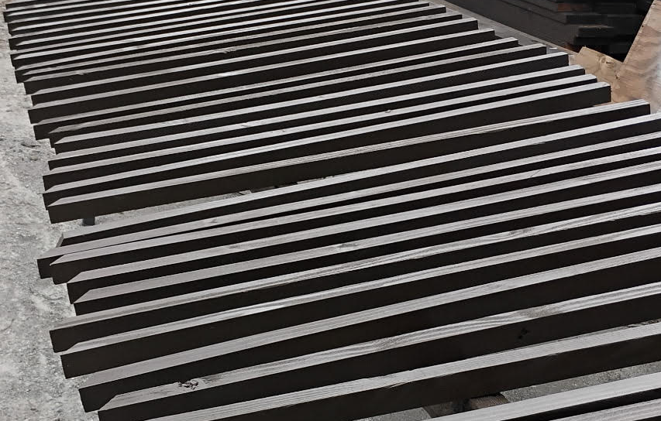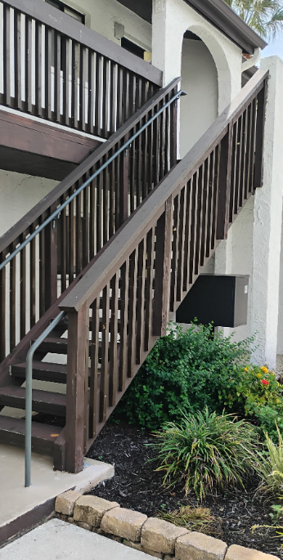

This project has required a significant amount of time, effort, and hands-on labor. We would like to recognize and thank our maintenance team, Joe and Dave, for their hard work and dedication. They have spent considerable time carefully cutting, sizing, preparing, and painting the pickets and components to ensure they are properly installed and finished.
Their commitment to taking on this work in-house has been greatly appreciated and has helped move this project forward while also helping the Association control costs.
Thank you, Joe Alix and Dave Smith, for all your hard work and continued dedication to our community!

STAIRCASE REPLACEMENT PROJECT
The Association is moving forward with a staircase replacement project to address the existing damage and deterioration of specific staircases. The project is intended to restore the staircases to a safe, durable, and code-compliant condition.
SOCOTEC will oversee and manage the project, including development of the scope of work, coordination of required inspections and approvals, and review of the proposed construction details.
The final project specifications, schedule, budget, and other related details are expected to be finalized by the end of September.

SHORELINE PROTECTION PROJECT
The shoreline-protection project is moving forward following permit approval.
Planned improvements include:
- Beachfront riprap
- Rock revetment
- Installation of gabions
- Stabilization of areas near the beachfront and boardwalk
Work on the Gabion Project is expected to begin soon. The project will be completed in phases to help maintain beachfront access and minimize disruption to residents and guests.
Once a contractor is selected, construction is expected to take approximately five weeks. The current tentative goal is for completion in late fall or around the holiday season, depending on scheduling, weather, and construction conditions.
The project currently includes approximately:
- 61 linear feet of gabions
- 381–382 linear feet of riprap and rock revetment
Following the initial gabion installation, additional stabilization work will take place near the beachfront and boardwalk areas.
We will continue to provide updates as the project progresses and appreciate everyone’s patience and cooperation during this important improvement to our community.
ELEVATOR IMPROVEMENTS
Planning for Safer, More Reliable Elevators
The Association is continuing to make progress with the planned refurbishment of all three elevators. The necessary equipment has been ordered and is expected to be received by the end of the calendar year.
Once delivered, the equipment will be stored securely by the elevator contractor in preparation for the upcoming refurbishment project. Additional information regarding the project schedule and anticipated work will be provided to owners as details become available.
Preparatory work and related upgrades are expected to take place later this year. The primary mechanical refurbishment is anticipated to begin on May 1, 2027.
To complete the mechanical work, each elevator may require a temporary four- to five-week shutdown. The work will be carefully coordinated to help minimize disruptions to residents and guests.
As the project schedule becomes more defined, the Association will provide additional information regarding timing, elevator availability, and anticipated impacts on residents.

WALKWAY REPAIRS
Inspections and repair proposals are being pursued for areas with delaminated or deteriorated concrete, particularly along first-floor walkways and landings.
Additional areas near the following locations will also be evaluated:
- Boardwalk
- Shoreline-access stairs
- Circular boardwalk area
Where practical, these repairs may be coordinated with the broader beachfront and shoreline-protection project to improve efficiency and minimize disruption.
AROUND THE PROPERTY
A few additional community projects and maintenance items are also moving forward:
Laundry-room door inserts/slats - Replacement options are being reviewed.
Roof power washing - Completed.
Carport door replacement and painting - Completed.
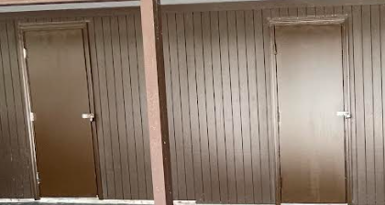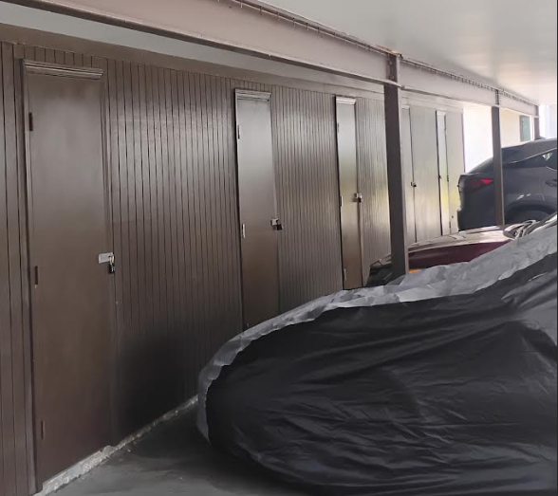
Enhancing appearance and condition of the property

POOL FURNITURE UPDATE
It’s here! We’re excited to announce that all of our new pool furniture has arrived and it’s in the correct color!
The furniture was originally delivered on Tuesday, September 8, 2026. Our Maintenance Manager, Joe Alix, quickly noticed that the furniture had arrived in the incorrect color before it was placed around the pool. Joe immediately brought the issue to our attention, allowing us to work with the vendor to have the furniture returned and corrected.
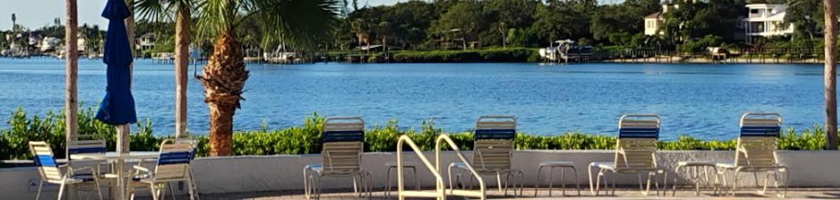
Today, the corrected furniture has arrived and is being unloaded! The furniture will be temporarily stored in the clubhouse until everything can be properly placed in its designated areas around the pool.
A special thank you to Joe Alix for his careful attention to detail and for making sure we received exactly what the Association ordered. His diligence helped ensure that our new pool furniture will look great and meet our expectations!
Thank you to our owners and residents for your patience and understanding throughout this process. We hope everyone enjoys the new pool furniture!
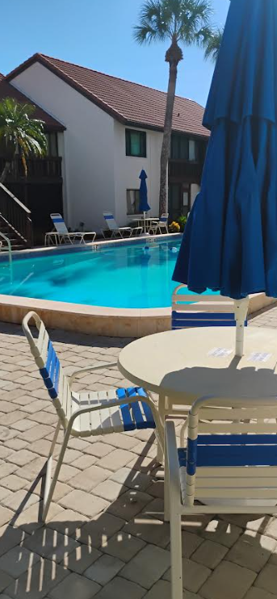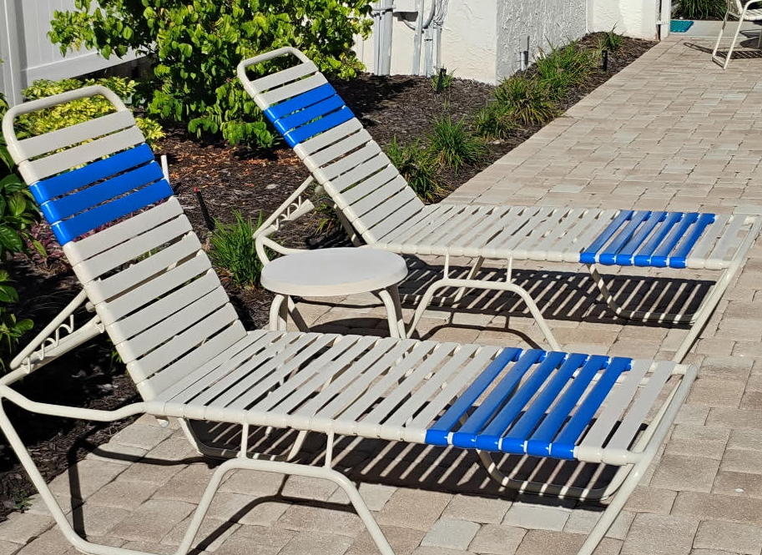
LOOKING AHEAD
The coming months will focus on completing inspections, reviewing engineering recommendations, obtaining project proposals, and coordinating the timing of several major improvements.
As schedules, costs, and construction plans become more definite, updates will be shared with the Castel Del Mare Community.
Thank you for your continued patience, cooperation, and support as we work together to maintain, protect, and improve our community.

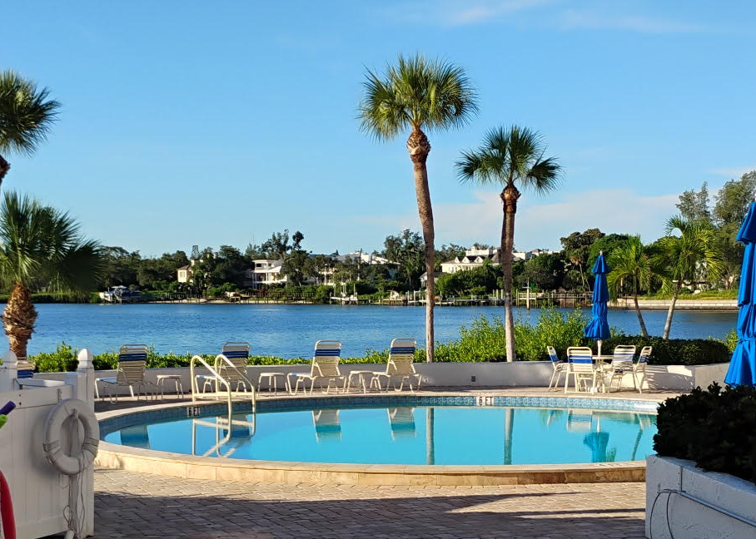

Working Together to Preserve Our Community & Its Shoreline

CDM CONTACT INFORMATION
CDM Website: www.casteldelmare.net
LCAM (License Community Association Manager): Jerry Thomas (cdm1478@gmail.com)
Office phone number: 941-927-1478
Office Hours: Monday-Friday 8AM–4PM
Office email address: cdm1478@gmail.com
Office address: 1620 Stickney Point Rd Sarasota, FL 34231
BOARD CONTACT INFO
President: Marcus Braz (marcus.braz.cdm@gmail.com)
Vice President: Graham Shorter (shorter50@att.net)
Treasurer: Mark Alfieri (mark.alfieri@gmail.com)
Secretary: Rick Gorrell (rickgorrell@comcast.net)
Director: Jim McGuire (jmcguire1656@gmail.com)
Director: Brendan Hall (jbfhall@aol.com)
LANDSCAPE COMMITTEE CHAIRS:
Colleen Lohnes (cdmlandscape34231@gmail.com)
Kathie Westpheling (cdmlandscape34231@gmail.com)
SOCIAL COMMITTEE:
Arlene & Rick Gorrell (arlene_gorrell@comcast.net)
Joanne & Brendan Hall (jbfhall@gmail.com)
Linda & Jim Waldera (tiezziwaldera44@gmail.com)
Cindy Slocik (slocik@hotmail.com)

